Please Mrs Butler by Allan Ahlberg


Please Mrs Butler
This boy Derek Drew
Keeps copying my work, Miss.
What shall I do?

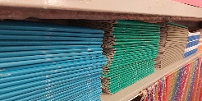
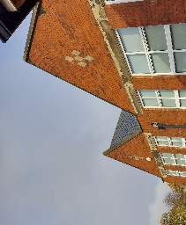
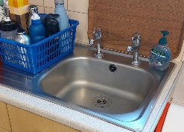
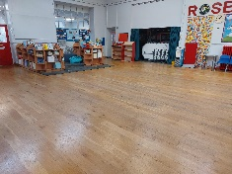
Go and sit in the hall, dear.
Go and sit in the sink.
Take your books on the roof, my lamb.
Do whatever you think.
Please Mrs Butler
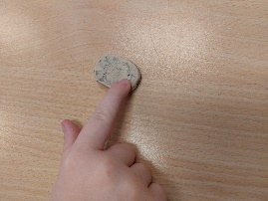
This boy Derek Drew
Keeps taking my rubber, Miss.
What shall I do?
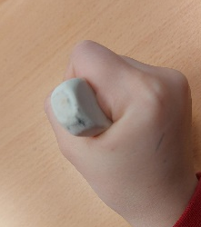

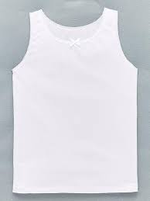
Keep it in your hand, dear.
Hide it up your vest.
Swallow it if you like, my love.
Do what you think is best.

Please Mrs Butler
This boy Derek Drew
Keeps calling me rude names, miss.
What shall I do?

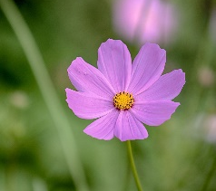

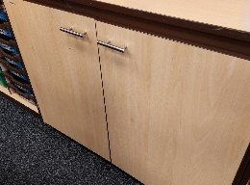
Lock yourself in the cupboard, dear.
Run away to sea.
Do whatever you can, my flower.
But don’t ask me.

